**Titanic Survival Prediction**

**Importing Libraries**



Upload widget is only available when the cell has been executed in the current browser session. Please rerun this cell to enable.

Saving tested.csv to tested.csv



PassengerId Survived Pclass \

0 892 0 3

1 893 1 3

2 894 0 2

3 895 0 3

4 896 1 3

.. ... ... ...

413 1305 0 3

414 1306 1 1

415 1307 0 3

416 1308 0 3

417 1309 0 3

Name Sex Age SibSp Parch \

0 Kelly, Mr. James male 34.5 0 0

1 Wilkes, Mrs. James (Ellen Needs) female 47.0 1 0

2 Myles, Mr. Thomas Francis male 62.0 0 0

3 Wirz, Mr. Albert male 27.0 0 0

4 Hirvonen, Mrs. Alexander (Helga E Lindqvist) female 22.0 1 1

.. ... ... ... ... ...

413 Spector, Mr. Woolf male NaN 0 0

414 Oliva y Ocana, Dona. Fermina female 39.0 0 0

415 Saether, Mr. Simon Sivertsen male 38.5 0 0

416 Ware, Mr. Frederick male NaN 0 0

417 Peter, Master. Michael J male NaN 1 1

Ticket Fare Cabin Embarked

0 330911 7.8292 NaN Q

1 363272 7.0000 NaN S

2 240276 9.6875 NaN Q

3 315154 8.6625 NaN S

4 3101298 12.2875 NaN S

.. ... ... ... ...

413 A.5. 3236 8.0500 NaN S

414 PC 17758 108.9000 C105 C

415 SOTON/O.Q. 3101262 7.2500 NaN S

416 359309 8.0500 NaN S

417 2668 22.3583 NaN C

[418 rows x 12 columns]







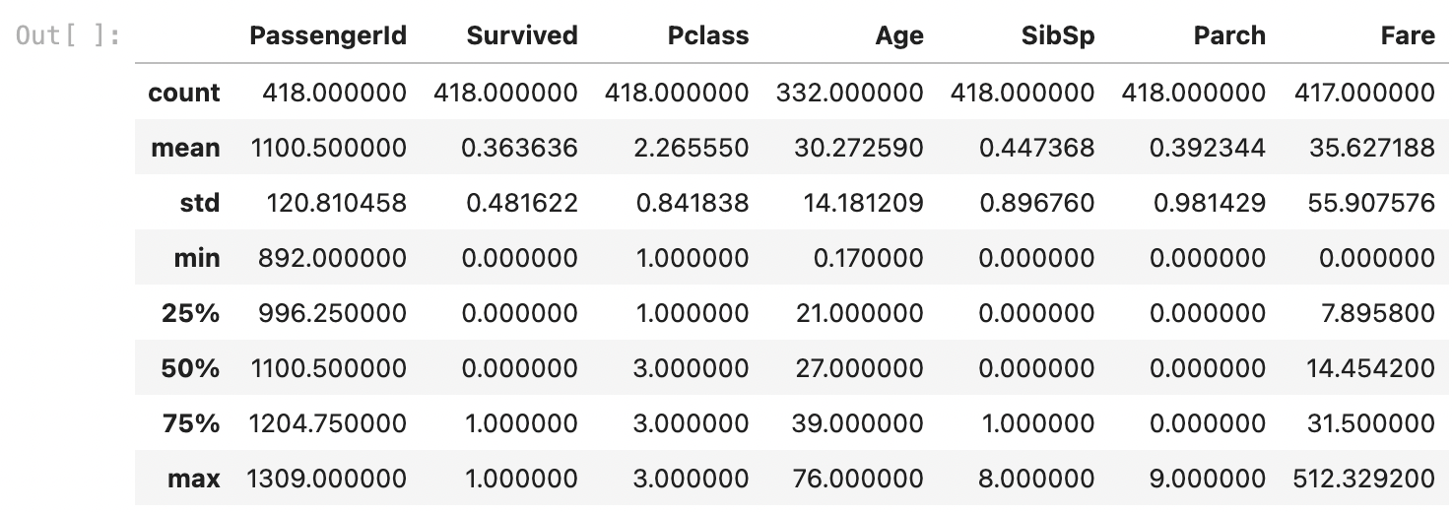



PassengerId 0

Survived 0

Pclass 0

Name 0

Sex 0

Age 86

SibSp 0

Parch 0

Ticket 0

Fare 1

Cabin 327

Embarked 0

dtype: int64



PassengerId int64

Survived int64

Pclass int64

Name object

Sex object

Age float64

SibSp int64

Parch int64

Ticket object

Fare float64

Cabin object

Embarked object

dtype: object





-> Q

-> S

-> C





PassengerId int64

Survived int64

Pclass int64

Name object

Sex int64

Age float64

SibSp int64

Parch int64

Ticket object

Fare float64

Cabin object

Embarked int64

dtype: object









# ****Visualization of the data****

<matplotlib.legend.Legend at 0x7c34dd681420>

<matplotlib.legend.Legend at 0x7c34dd422e60>

# ****Splitting the data into training and testing****



# ****Developing the model****



LogisticRegression(max_iter=200, solver='liblinear')

**In a Jupyter environment, please rerun this cell to show the HTML representation or trust the notebook.  
On GitHub, the HTML representation is unable to render, please try loading this page with nbviewer.org.**

# ****Testing the model on test data****



# ****Getting the accuracy of our model****

Logistic regression accuracy:

92.86%